PSSI Science Project Reporting Template

️ | The PSSI Implementation Team is compiling a technical report to demonstrate the important research and advancements made by the Science Branch through the PSSI funding. The technical report will include a 3-4 page summary (including graphics and figures) for each project to show their key results and findings. Please fill in the following fields and sections for your project to be included in the report. Feel free to include and draw from any reports or presentations previously created through your research.  A plain language science bulletin will also be created to follow up on last year’s “DFO Pacific Region Science Bulletin, 2024. New research and monitoring for Pacific salmon and their ecosystems.” While the first bulletin introduced project backgrounds, methods, and timelines, this new bulletin will highlight the projects’ results, key findings, and conclusions with links to reports and data available. The bulletin will include a 1-2 page summary for each project gleaned from the content entered below.  ️ Completed forms are due January 7, 2026.  *Please include or send separately any graphics or pictures (with photo credits) that will help promote the projects.

PART 1: PROJECT METADATA

General Project Information
Project ID (number) | Project Title
2442 | Graduate Research into 1) habitat use by juvenile Chinook Salmon in the Canadian Okanagan River and Lake system and 2) predation on juvenile salmon in the Canadian Okanagan and Lake system
Project Leads | Collaborations and External Partners
Lauren Weir (DFO)  Tommy Pontbriand (DFO) | Thompson Rivers University (TRU)  - Dr Brian Heise  - Selena Carl (MSc student)  - Torrie Bell (MSc student)  Okanagan Nation Alliance (ONA)  - Elinor McGrath
Location (if applicable)
Okanagan River and Lake system

Geographic and Stock Information
Salmon species (if applicable) | Waterbodies (if applicable)
Chinook | Okanagan River and Lake system
Life history phases (if applicable) | Region
Ocean-type (sub-yearling) summer population | Okanagan
Stock (if applicable) | Population (if applicable)
Canadian Okanagan | Canadian Okanagan
Conservation Unit (if applicable)
CK-01

🧰 PART 2: PROJECT METRICS

Project Outputs
Include any anticipated outputs denoted as (in progress). Please include links to any outputs available online so they can be referenced in the report.
List scientific publications and technical reports (with links)
Selena Carl, MSc Thesis, Thompson Rivers University – Just Keep Swimming- Tracking Endangered Juvenile Okanagan Chinook Salmon (Oncorhynchus tshawytscha) Throughout the Okanagan River System (in progress)

Torrie Bell, MSc Thesis, Thomson Rivers University – Investigating Predation on Juvenile Sk’lwist (Chinook Salmon Oncorhynchus tshawytscha) in the Okanagan Basin: Diet Composition and Habitat-Specific Impacts of Smallmouth Bass (Micropterus dolomieu) (in progress)
List datasets generated (with links)
Datasets are not currently available. They will be shared with the final deliverables in March 2026 (in progress).
Describe dataset locations and data management systems
Datasets not yet available, location to be determined (in progress).
List code, programs, or other software created (with links)
Not applicable.
List communication or social media products

Conferences/Presentations and Posters

Masters of Environmental Science Showcase
  - Organization: Thompson Rivers University
  - Date: March 7th, 2024
  - Type: Presentation – Torrie Bell, Poster – Selena Carl
- Kamloops Naturalist Club
  - Date: November 2024
  - Type: Presentation –Selena Carl

Beyond the Blue: A Conservation Conference
  - Organization: British Columbia Metis Foundation
  - Date: January 18th 2025
  - Type: Presentation (30 minutes long)

Invasives 2025 annual forum and AGM
  - Organization: Invasive Species Council of BC
  - Date: February 24 – 27th, 2025
  - Type: Presentation – Torrie Bell

Pacific Ecology and Evolution Conference – Bamfield BC
  - Date: March 2025
  - Type: Presentation – Selena Carl

Masters of Environmental Science Showcase
  - Organization: Thompson Rivers University
  - Date: March 6, 2025
  - Type: Poster – Torrie Bell

American Fisheries Society 2025 Washington – British Columbia Chapter Conference
  - Organization: American Fisheries Society
  - Date: March 10 – 13th, 2025
  - Type: Presentation – Torrie Bell, Presentation and Poster – Selena Carl
  - Award: Best Student Presentation Award (Torrie Bell)

American Fisheries Society Western Division Annual Meeting
  - Organization: American Fisheries Society
  - Date: May 11 – 15th, 2025
  - Type: Presentation – Torrie Bell, Selena Carl

Invasive Species Research Conference
  - Organization: Invasive Species Council of BC
  - Date: May 13- 15, 2025
  - Type: Presentation – Dr Brian Heise

BC Nature Spring Conference
  - Date: May 2025
  - Type: Presentation – Selena Carl

Nicola Naturalist Society
  - Date: November 2025
  - Type: Presentation – Selena Carl

Integated Vegetation Management Association of BC
  - Date: November 2025
  - Type: Presentation – Selena Carl

Pacific Salmon Science Symposium
  - Organization: Fisheries and Oceans Canada
  - Date: December 2nd, 2025
  - Type: Presentation – Tommy Pontbriand

New Zealand and Australian Freshwater Sciences Society Joint Conference
  - Date: December 2025
  - Type: Presentation – Selena Carl

Communications:

Four Food Chiefs Gathering – Okanagan Nation Alliance
  - Date: November 13-14th, 2024
  - Format: In-person community engagement
  - Description: Torrie Bell participated in one day of the gathering on November 13th, focusing on information sharing and utilizing the enowkinwixw model through the four food chiefs. She attended workshops, presentations, and keynote speakers. During intermission breaks, she shared her research informally with community members at the ONA information table and heard stories and shared knowledge from attendees.

Habitat Conservation Trust Foundation
  - Product: Scholarship recipient bio and social media feature
  - Description: Al Martin HCTF Conservation Scholarship recipient profile highlighting this research.
  - Links:
    - bio provided on their website 2025-Recipient-Bios_Torrie_05.pdf
    - LinkedIn: https://www.linkedin.com/posts/habitat-conservation-trust-foundation_scholarship-student-highlight-torrie-nicholas-activity-7384664541781094401-blEU?utm_source=share&utm_medium=member_desktop&rcm=ACoAACec60MBHcMS2j0QIIjAQuQ80e7KPbEnOvk
- FishSens Magazine | Evaluating the Survival of Chinook Salmon in the Okanagan River System - FishSens Magazine
  - Journal article where Selena Carl is featured as an interviewee about her research.
- Community Bursary Spotlight: Selena Carl | Pacific Salmon Foundation
  - Article where Selena Carl is featured as a bursary recipient and was interviewed about her research.
- TRU master’s student awarded for salmon conservation – TRU Newsroom
  - Web news article where Selena Carl’s research is spotlighted.
- Seven TRU students awarded prestigious conservation scholarships from HCTF – TRU Newsroom
  - Selena Carl mentioned as a scholarship recipient.
- 2025 Freshwater Fisheries Society of BC Scholarship Recipients Announced - Freshwater Fisheries Society of BC
  - Selena Carl mentioned as a scholarship recipient.

List and describe field work completed
Juvenile Chinook survival and habitat use:
- Subyearling Okanagan Chinook from the kł cp̓əlk̓ stim̓ hatchery (n = 547) were implanted with ATS SS400 injectable acoustic transmitters in late May 2024.
- Fish were released at dusk on 25 May 2024 in two spatially distinct groups to create different migration histories.
- A network of autonomous acoustic receivers was deployed from Okanagan Falls to Osoyoos Lake (21 May to 8 August 2024).
- Mobile surveys were completed by boat, kayak, and wading, totaling 42 survey days across Vaseux Lake, Osoyoos Lake, and the river between late May and early August.
Juvenile Chinook predation by Smallmouth bass
- Targeted angling for smallmouth bass was conducted in the Okanagan River, Vaseux Lake, and Osoyoos Lake from 3 May to 7 August 2024.
- Upon capture, fish were immediately euthanized then measured for total length (mm), weighed on a digital balance scale (g), and sexed by visual inspection of the reproductive organs.
- The entire digestive tract was removed, injected with 90% ethanol for preservation, and frozen for later laboratory analysis.
List and describe samples collected/analyzed (number of samples)
n=547 sub-yearling Chinook acoustic tagged and released, followed by monitoring movement and survival during their downstream migration in the Okanagan River and Lake system.

n=196 smallmouth bass stomach contents collected, n=73 analyzed with visual taxonomy and n=162 analyzed with DNA metabarcoding.
List and describe large capital assets or equipment acquired
Not applicable.

PART 3: WRITTEN CONTENT

Highlights
Please summarize in 2-3 bullets:
- The main idea of the project
- Key findings
- Implications of these findings for salmon and decision-makers
- For a more technical audience, but still as plain language as possible
The objective of this project was to understand factors influencing the survival of juvenile Chinook Salmon in the Okanagan River and Lake system. We found that survival is low during the downstream migration of sub-yearling Chinook in the spring and early summer. Disturbed rearing habitat, high water temperatures, and predation pressure from smallmouth bass were identified as the main threats to Okanagan Chinook juvenile survival. This new knowledge will help us target recovery efforts for this endangered population.

Background
Please provide 1-2 paragraphs to summarize
- The relevant biological, environmental, and/or management context
- What knowledge gap or demand were you trying to fill?
- Collaboration and partner relationships
The Canadian Okanagan Chinook population is currently the only Columbia River basin Chinook population in Canada. Chinook escapements to the Okanagan River have been extremely low (less than 100 spawners annually) and many habitat challenges are preventing the recovery of the population. Okanagan Chinook were assessed as Endangered by COSEWIC in 2017, and the population is under review for listing under the Species at Risk Act. Some knowledge gaps that originated from those assessments were uncertainty around juvenile survival and factors influencing it.

To answer this knowledge gap, we partnered with Thompson Rivers University to support two graduate students to study factors influencing the survival of juvenile Chinook Salmon in the Okanagan River and Lake system. The project was also developed and implemented in collaboration with the Okanagan Nation Alliance’s fisheries biologist Elinor McGrath.

️ Methods and Findings
Please insert a few paragraphs to summarize:
- Main methods used
- Products and tools produced
- Advancements in methodology, technology, and application
- Advancements in communication and knowledge transfer
- Key results and information generated
Habitat use and survival:
Subyearling Chinook (n=547) raised in the kł cp̓əlk̓ stim̓ hatchery were implanted with ATS SS400 injectable acoustic transmitters. They were released in two groups, with group A (n=273) released in the Okanagan River below Vertical Drop Structure (VDS) 17 and above Vaseux Lake, and group B (n=274) released downstream of Vaseux lake below McIntyre Dam. A network of 15 ATS SR3001 autonomous receivers was deployed from Okanagan Falls to Osoyoos Lake between 21 May and 8 August, 2024). Receivers were clustered into 7 detection sites, placed to form acoustic “gates” at lake inlets and outlets, narrows and channel constrictions, and potential rearing/migration corridors. An ATS SR3017 mobile receiver with hydrophone was used to survey shallow side channels, deeper offshore areas beyond stationary coverage, and upstream and downstream of VDS structures. The proportion of fish detected decreased sharply for both release groups as fish migrated downstream, which translated to low survival in both release groups. Tag burden was not deemed a source of direct mortality, but could have increased susceptibility to predation.

Smallmouth bass diet and predation:
Targeted angling was conducted in the Okanagan River, Vaseux Lake, Osoyoos Lake from May 3 to August 7, 2024. The dominant species captured were smallmouth bass, which comprised 76% of the total catch (n=196), followed by Northern Pikeminnow (16%, n=41) and Yellow Perch (4%, n=11). There was a spatial shift in the distribution of smallmouth bass caught during the study. In May, less than half (45%) of smallmouth bass were caught at Vertical Drop Structures (VDS), but the proportion of smallmouth bass captured at VDS structures increased to 100% and 80% in June and July, respectively. Bass were observed utilizing rocky substrate and rip rap below the VDS structures to ambush prey. Diet content visual analysis was performed on a subsample of 73 of the total 196 smallmouth bass. A total of 162 fish stomach samples were sent for DNA barcode sequencing. Chinook salmon was only detected once in the DNA samples, but direct evidence of bass predation on juvenile Chinook was obtained by recovery of an acoustic tag used in the juvenile migration and habitat use study. DNA metabarcoding identified a diverse assemblage of 146 unique prey taxa. Aquatic insects (Diptera, Ephemeroptera, Trichoptera), invasive fish (smallmouth bass, yellow perch, common carp), and native fish (prickly sculpin, mountain whitefish, sockeye/kokanee, chinook) were the most common prey items in smallmouth bass stomach contents.

Insights
Please insert a few paragraphs to summarize:
- What this project has added to knowledge about salmon populations, health, or ecosystems.
- How this project informs salmon management:
  - decisions
  - policy guidance
  - trade-offs
  - planning
- Addition of knowledge to understanding:
  - limiting factors/stressors/threats/ pathways of effects/risks
  - biologically significant thresholds
  - cumulative impacts
- Sources of uncertainty
The research conducted through this project added greatly to the limited knowledge of juvenile Chinook survival in the Okanagan River and Lake system.

The acoustic telemetry study revealed that juvenile Chinook survival is low during their spring outmigration in the Okanagan River. It identified critical freshwater mortality hotspots in Vaseux Lake, in the Okanagan River, and in the northern portion of Osoyoos Lake. This mortality was associated with warm water temperatures and habitat constraints, and provides evidence for supporting habitat restoration strategies to increase juvenile survival. Proposed actions include:
- Reconnecting side channels
- Re-naturalizing riparian zones
- Adding deep pools, woody debris, and cover
- Managing macrophyte growth
- Adjusting dam operations for cold water inflow protection
- Adapting hatchery release strategy (timing and location) to maximize juvenile survival

The predation study revealed that predation pressure by native and invasive fish species, especially by smallmouth bass, is likely high and contributes to the low survival of juvenile Chinook in the Okanagan River and Lake system. It also identified predation hotspots at Vertical Drop Structure (VDS) sites on the Okanagan River. Proposed actions to mitigate the impacts of smallmouth bass predation include:
- Reduce predation hotspots at VDS sites with restoration efforts to remove or modify existing structures
- Targeted smallmouth bass removal in the Okanagan River and Lake system with electrofishing or angling programs
- Protect and enhance rearing habitat for juvenile Chinook by supporting the habitat restoration strategies listed above

⏩ Next Steps
Please insert 1-2 paragraphs to summarize:
- Remaining knowledge gaps and recommendations for future studies
- How can/should the project findings be operationalized for salmon conservation and management?
The findings from this project should be considered in the rebuilding and conservation plan of this endangered conservation unit, as it identified specific and tangible actions that have the potential to increase juvenile Chinook survival, productivity, and abundance of the CU.

Remaining knowledge gaps and recommendations for future studies include:
- Using predator-detecting acoustic tags to determine juvenile mortality from predation and finer-scale movement data to elucidate habitat use throughout the migration corridor
- Estimating the smallmouth bass population size in the Okanagan River and Lake system to quantify the predation pressure on juvenile Chinook
- Understanding the role of predation from other native and invasive piscivorous fish and avian predators on juvenile Chinook survival

📈 Tables and Figures
Please provide captions and numbering for any tables and figures. Graphics can be copied below or e-mailed separately.
- Include a brief caption with each figure and table in the box below
- Number each table and figure, and include references in the above sections where appropriate.
- 1-3 figures are recommended per project
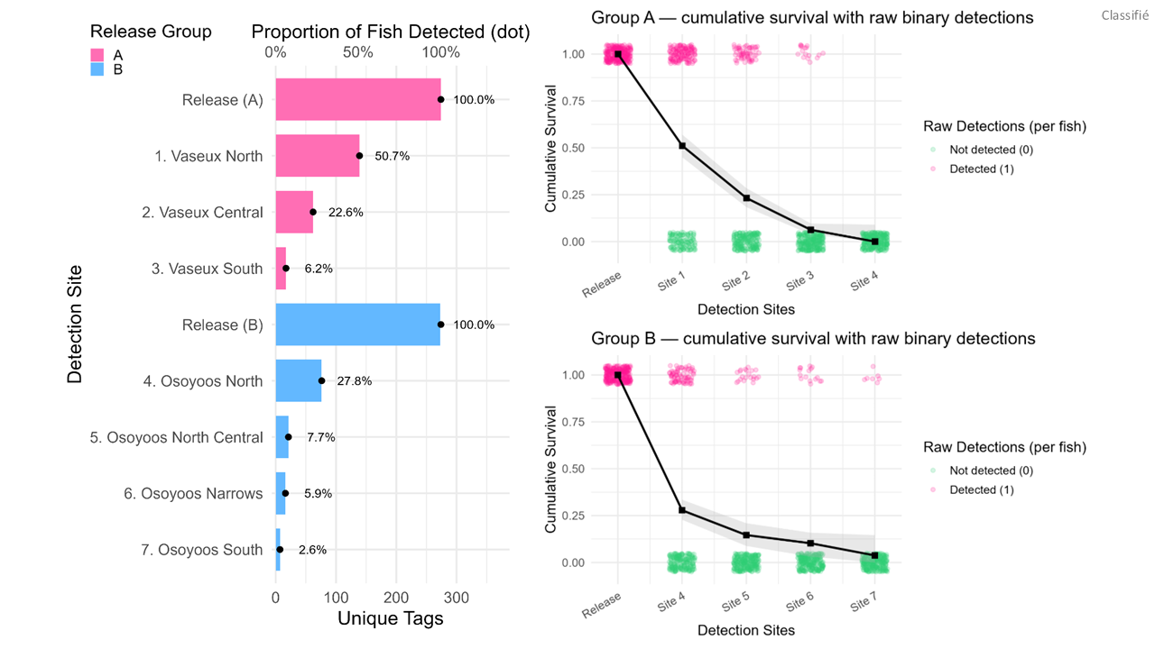

Figure 1: Proportion of acoustic tagged juvenile Chinook detected at downstream detections sites and resulting survival curves for release Group A (n= 273 upstream of Vaseux Lake) and B (n=274 downstream of McIntyre Dam). In both release groups, there is a sharp decline in the proportion of fish detected and survival is low during the downstream migration.

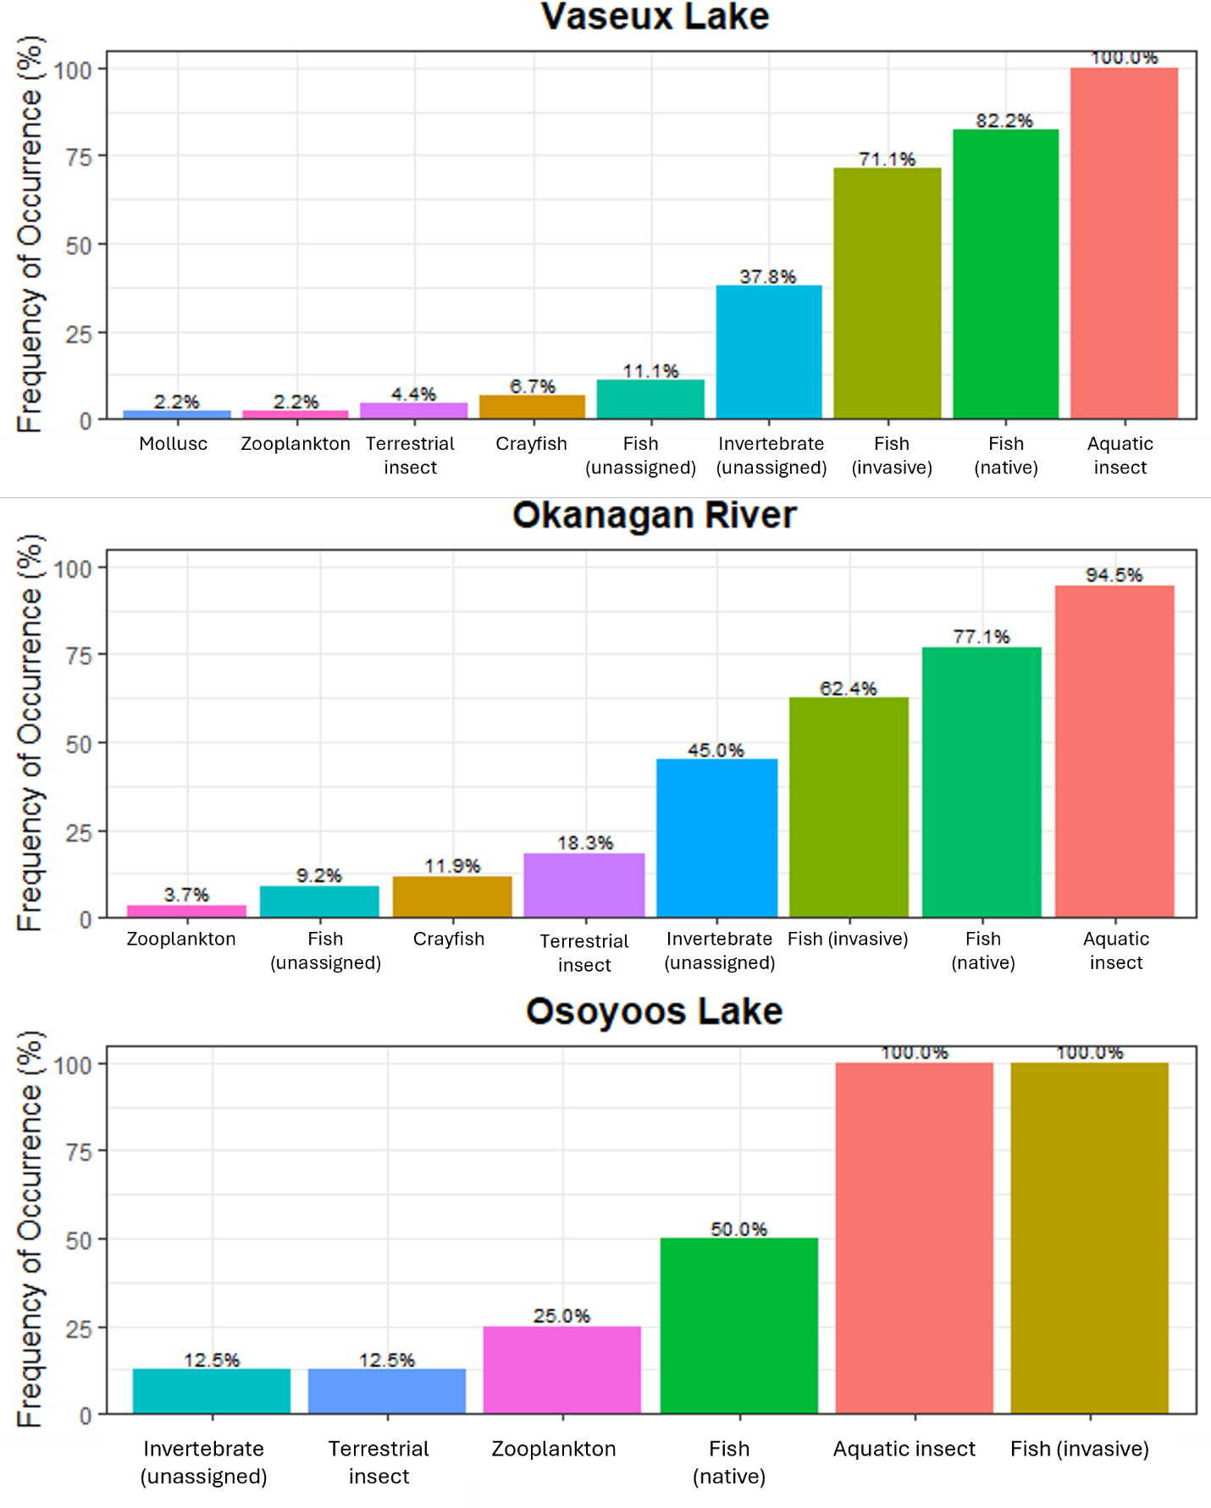
Figure 2: DNA metabarcoding stomach content analysis of n=162 smallmouth bass (Micropterus dolomieu) captured at various locations in the Okanagan River and Lake system. Aquatic insects (Diptera, Ephemeroptera, Trichoptera), invasive fish (smallmouth bass, yellow perch, common carp), and native fish (prickly sculpin, mountain whitefish, Sockeye/kokanee, Chinook) were the most common prey items identified.

Table 1: Total length (TL) and weight of the 196 smallmouth bass (Micropterus dolomieu) captured in the juvenile Chinook predation study. Bass were captured by angling in the Okanagan River and Lake system and were sacrificed upon capture for stomach content analysis.

Location | Month | n | TL (mm ± SD) | Weight (g ± SD)
Okanagan River | May | 88 | 290.5 ± 65.9 | 440.0 ± 381.7
Okanagan River | June | 15 | 291.4 ± 68.7 | 424.1 ± 382.9
Okanagan River | July | 35 | 243.7 ± 55.1 | 245.2 ± 264.6
Osoyoos Lake | May | 1 | 232.0 ± NA | 175.0 ± NA
Osoyoos Lake | June | 8 | 316.8 ± 87.3 | 550.0 ± 636.1
Vaseux Lake | May | 19 | 268.9 ± 59.1 | 324.1 ± 228.5
Vaseux Lake | June | 18 | 314.6 ± 67.8 | 509.8 ± 310.6
Vaseux Lake | July | 12 | 274.5 ± 55.8 | 328.7 ± 165.2
Total |  | 196 | 282.2 ± 66.8 | 395.6 ± 354.1

📈 References
Include full references for any publications referenced in other sections. Please format references in Harvard style according to Instructions to Authors for the Canadian Journal of Fisheries and Aquatic Sciences, at Canadian Science Publishing.
None

